Now in this lesson we are going to create a project named 2D Game Project which is a 2
D Project so the component will be 2D (Built-In Render Pipeline)
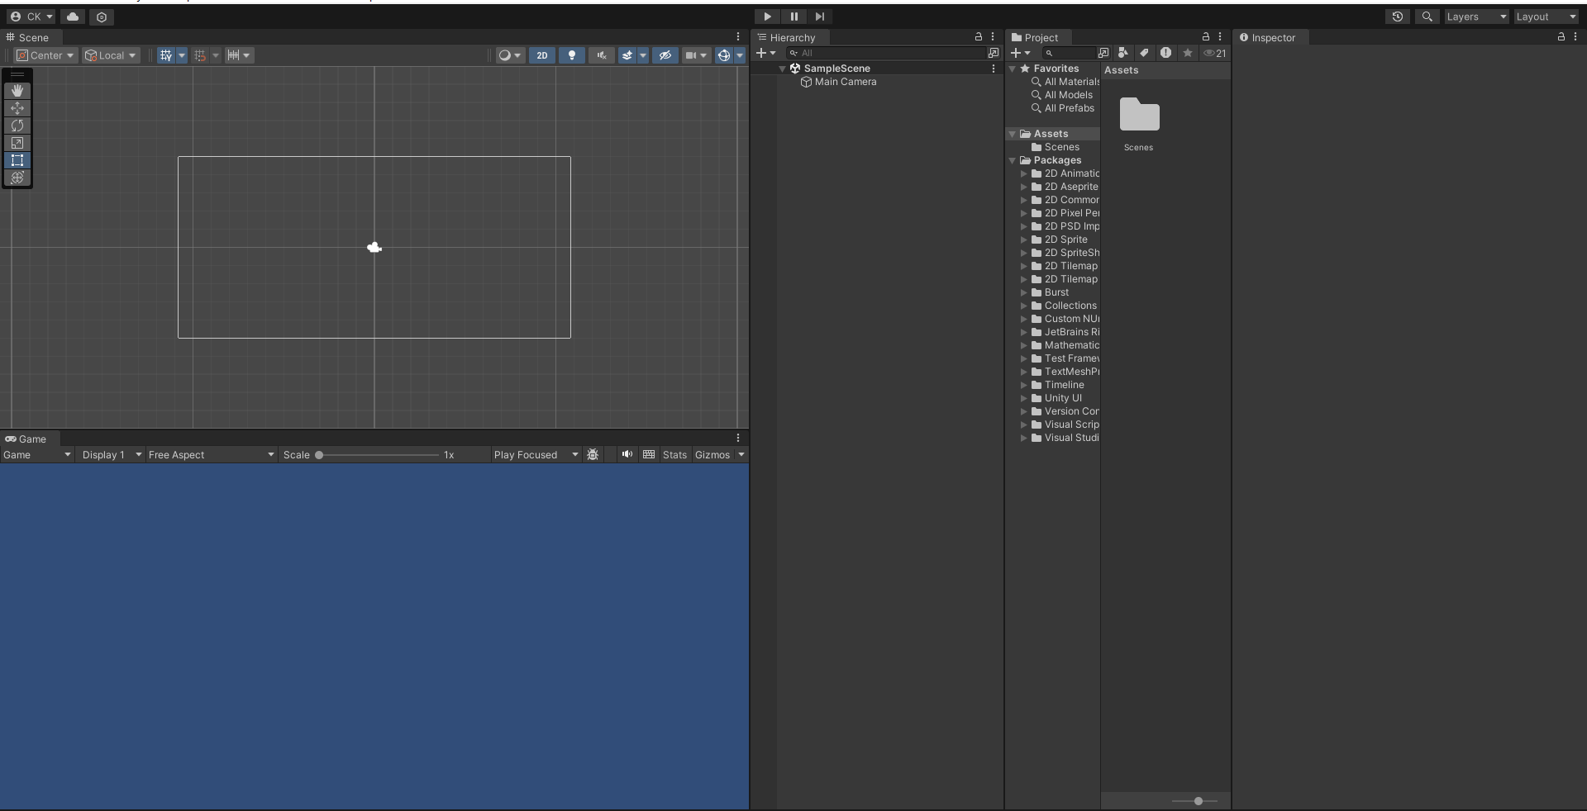
Note:-
Once the layout is chosen the next new project is going to be same layout.
Now our new project window is opened like below
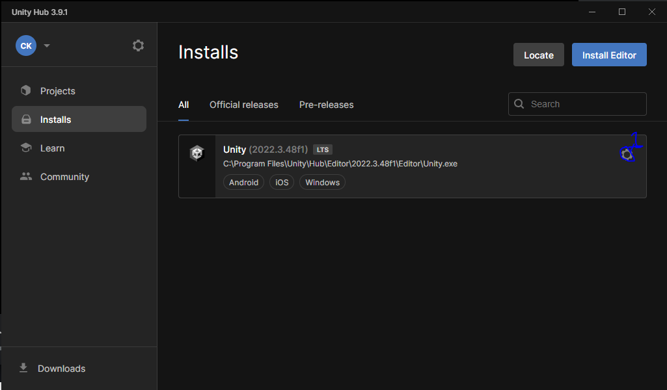
This project will be made for Android so make sure that android build tool is installed on your computer
So in unity hub go to installs and then choose the editor you have made project of and then go to gear option as marked above.
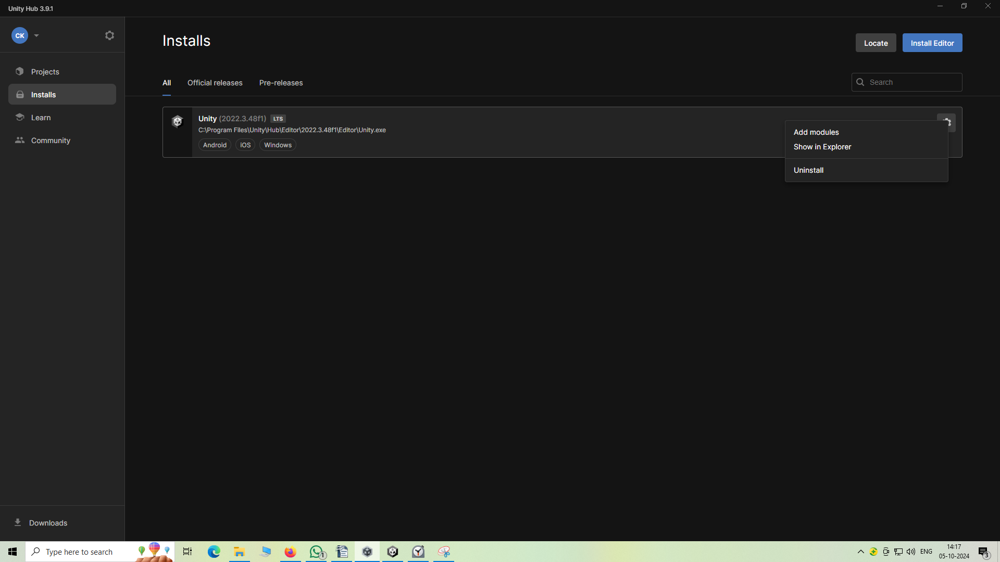
And then a submenu will be opened and in that go to add modules
and now you will be shown to same window you had seen while installing an editor.
Like below
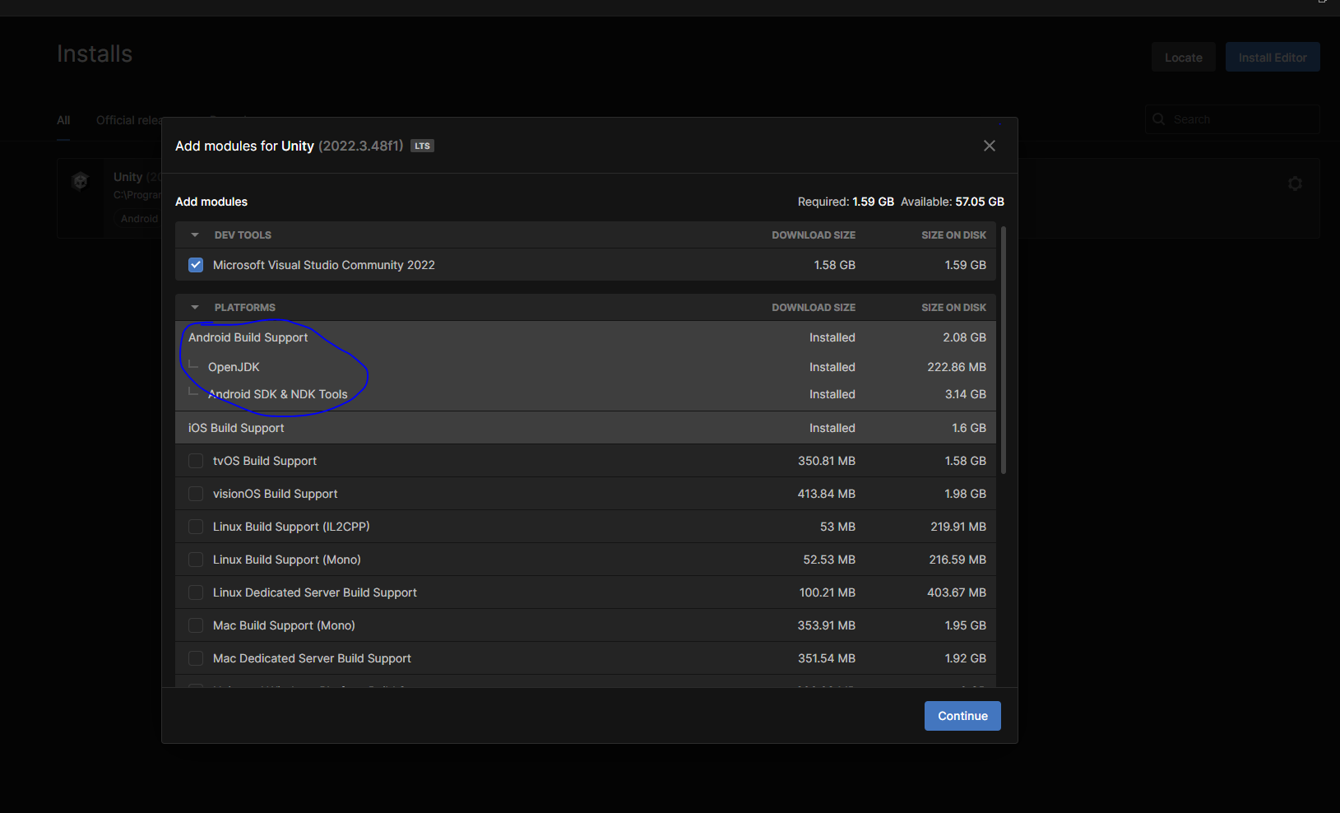
and make sure that Android Build support is already installed and you will know it if there is bo checkbox beside its name.
If it is not installed then a checkbox will be shown beside the Name of the component
If it is not installed then otherwise you will not be able to build for Android
Now go to file
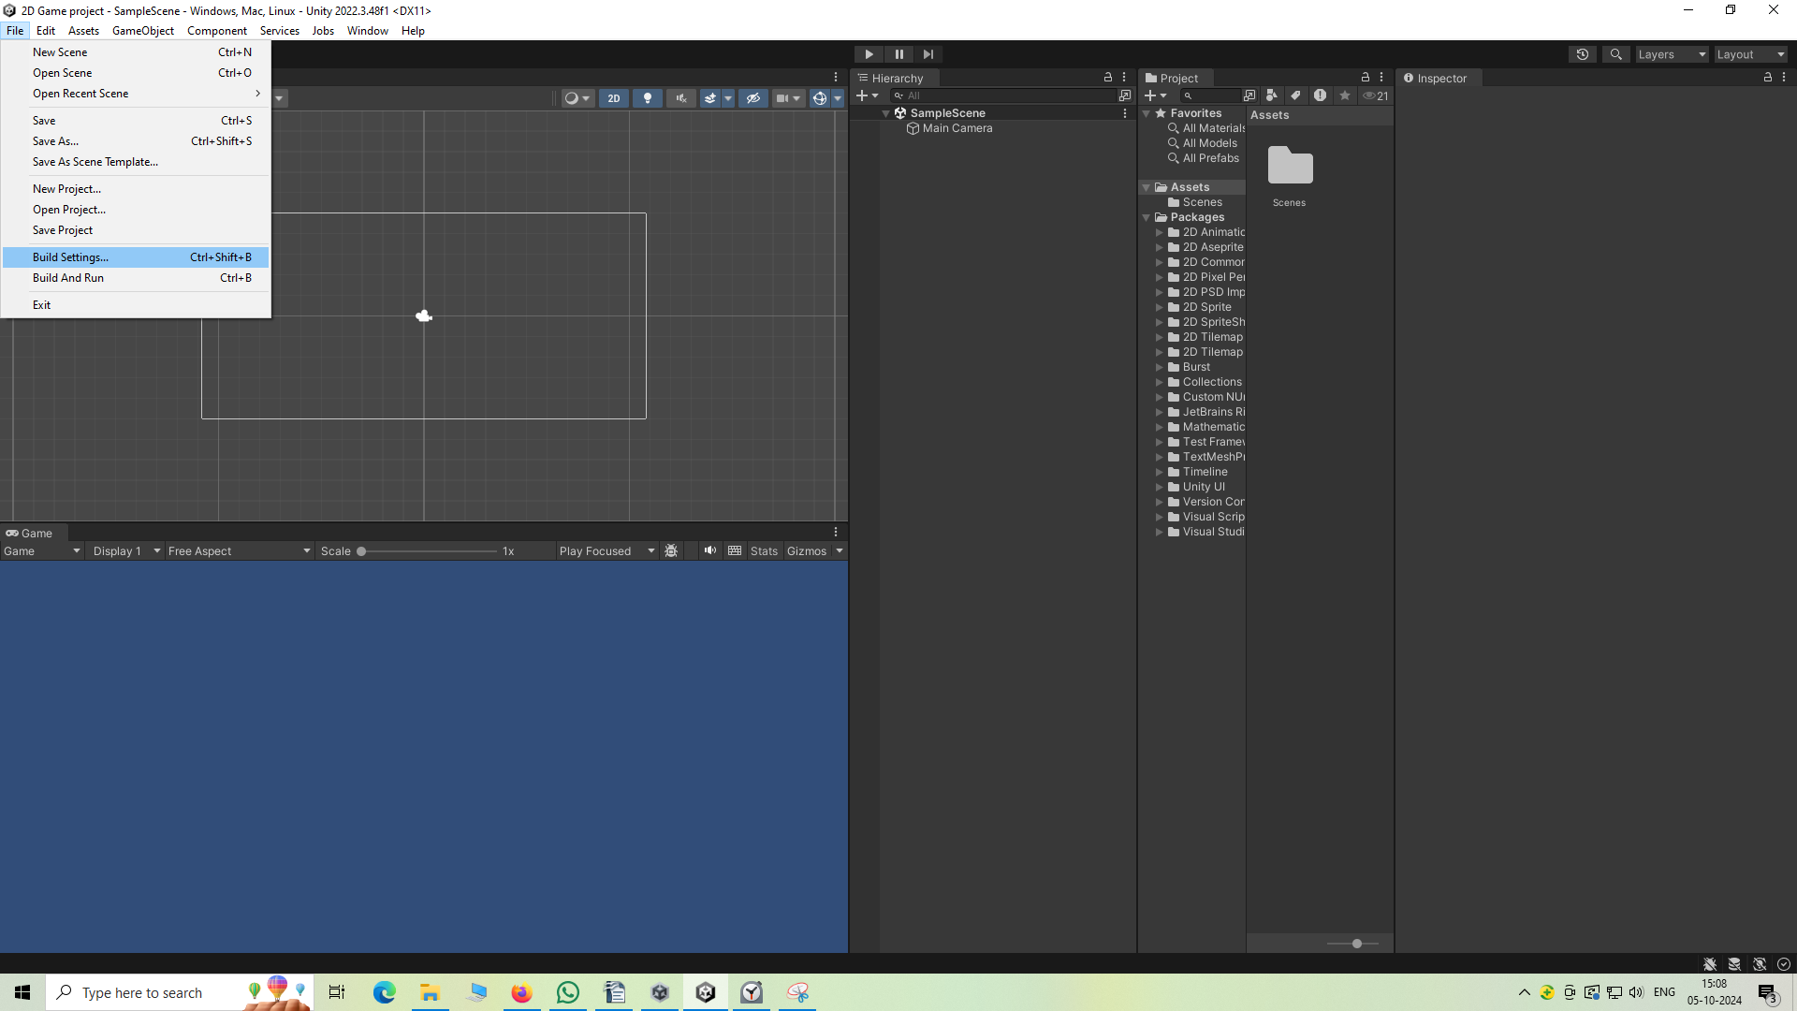
and then in the submenu opened go to Build setting and after clicking on it a new window will be opened
like below

you can see the unity symbol is beside the Window Mac linux in marked above which means it will mak games for Window, Mac or Linux but if we want to make games for Android select the Android in the list
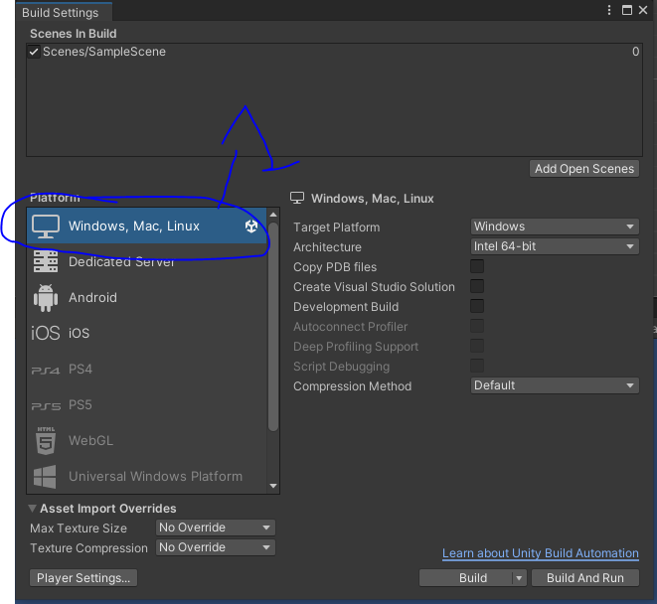
and then click on switch platform as marked below which take place of build button after choosing Android in the list

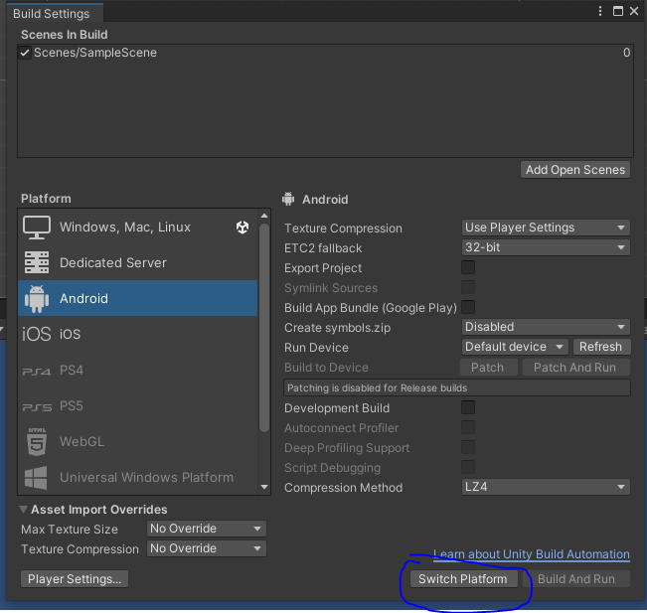
and then you can see unity symbol beside android as below
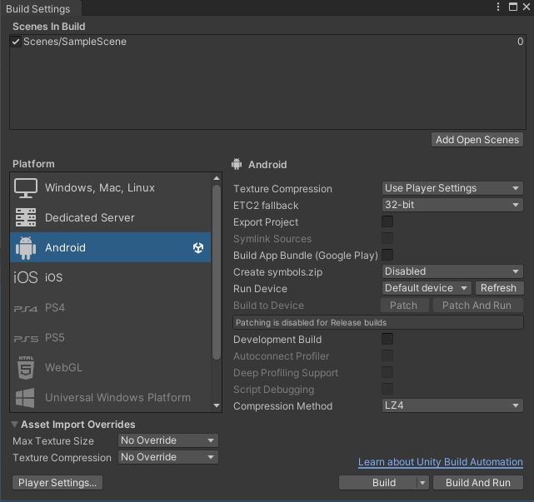
That means our current platform is android
Now in the title bar you can asee the android mentioned
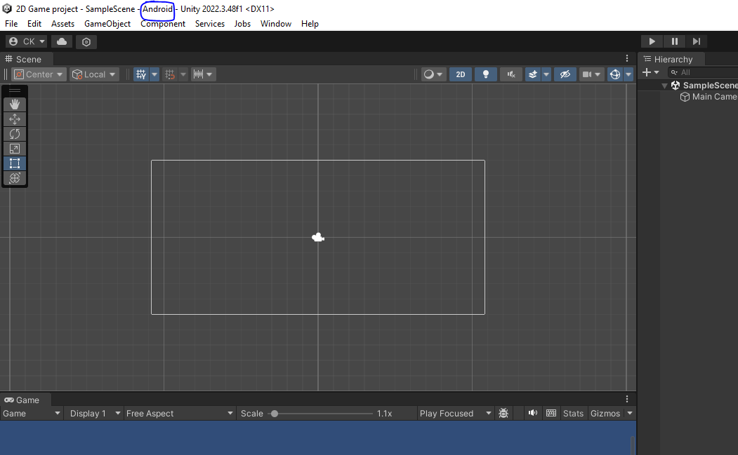
Now go to Game tab and then go to the area wher free aspect is written by clicking on it a submenu will be opened and then in submenu go to 16:9 portrait
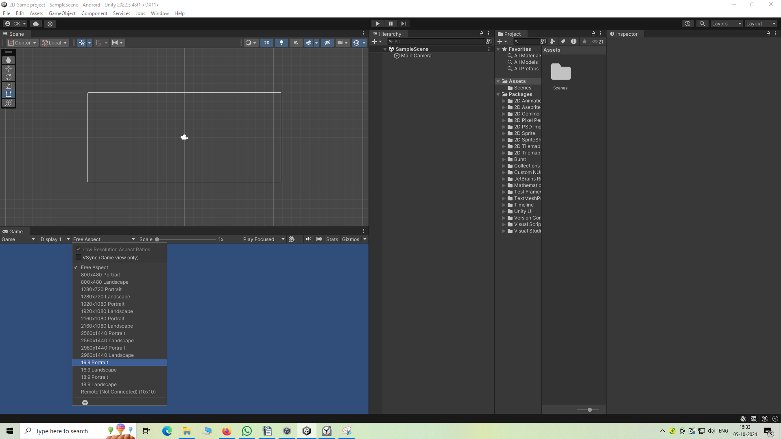
So this is the mobile resolution we are targeting.
If you want you can use other resolution we want
you can also choose 1080 X 1920 resolution
(I think by aspect ratio we are targeting various resolution which come under the ratio of 16:9 portrait but by 1080 X 1920 pixel we are getting specific here)
Now we go to Project panel as marked below
I think you can see here the folder structure which will be used for making the game possible
and i think in game tab we see the how it will look when the game will be played
And now in side our project tab we have assets folder and then inside that we have scenes folder
and then inside that we have simplescene
Note:-
I think that assets folder contains all the assets inside our game.
The asset can contain sample scene, or ay other things used inside our game

The scene folder contains the default scene names as SampleScene
We now rename the scene by right clicking on it and then choose rename inside the submenu like we do generally
and then we will make new folder inside asset folder and then import assets in that folder
So to make a new folder inside another folder
Note:-
Inside Project panel there is a subpanel showing what are the contents inside our folder
the subpanel is marked as below

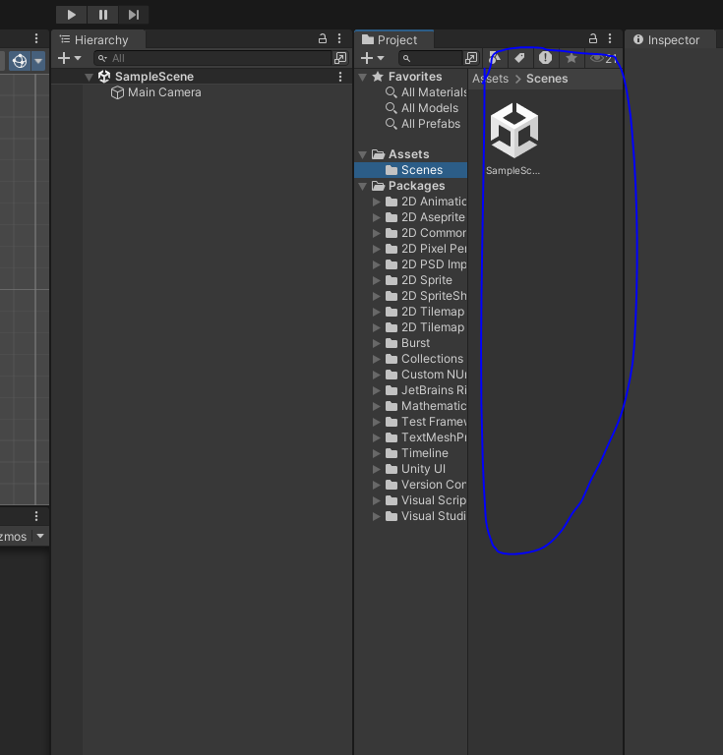
we right click in any part of the subpanel and then in submenu go to create and then to folder
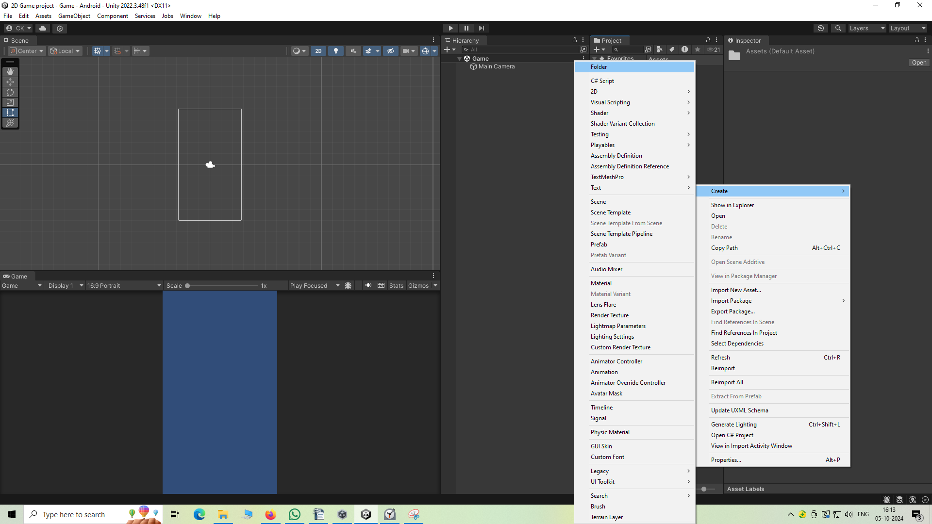
or you can right click on the folder inside which you want ot create something new and again follow the procedure as above.
We will name this new folder as sprites(Inside this folder we will keep all the images used inside our game)
and now we will create another folder inside assets that is Scripts (may be this is the place where your code will be kept)
We again create folder inside asset folder named prefab(I don't know)
Now project panel look like below
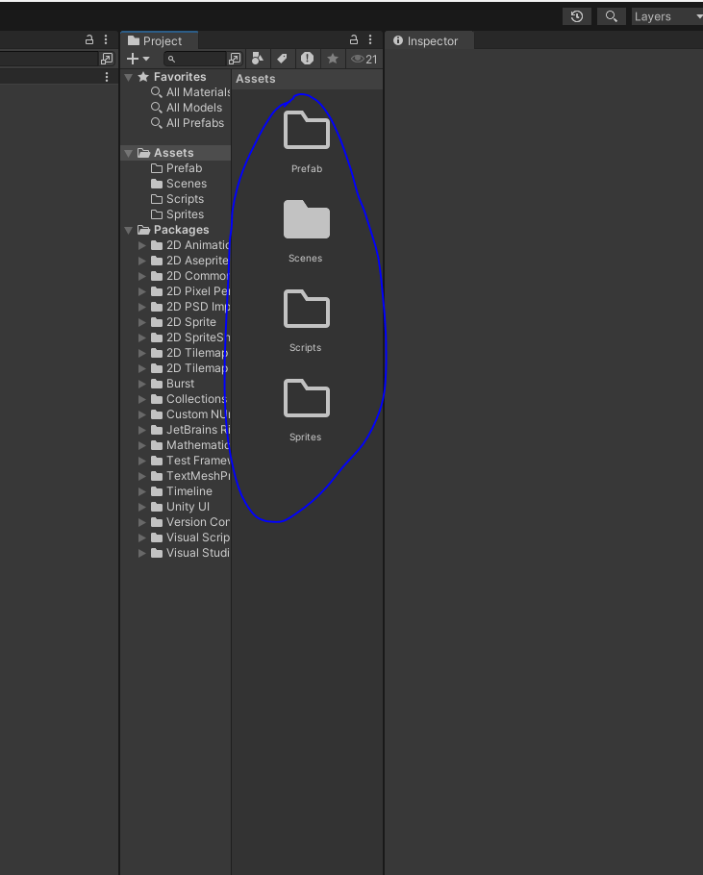
I think the name inside the asset folder start with capital letter
Now we will go to sprites folder and then import 2d sprites that we are going to use for our game
so we are going to import them to our unity by dragging and dropping the files to the Project panel mini panel like below from where you kept your sprite files (I think they are basically some images)
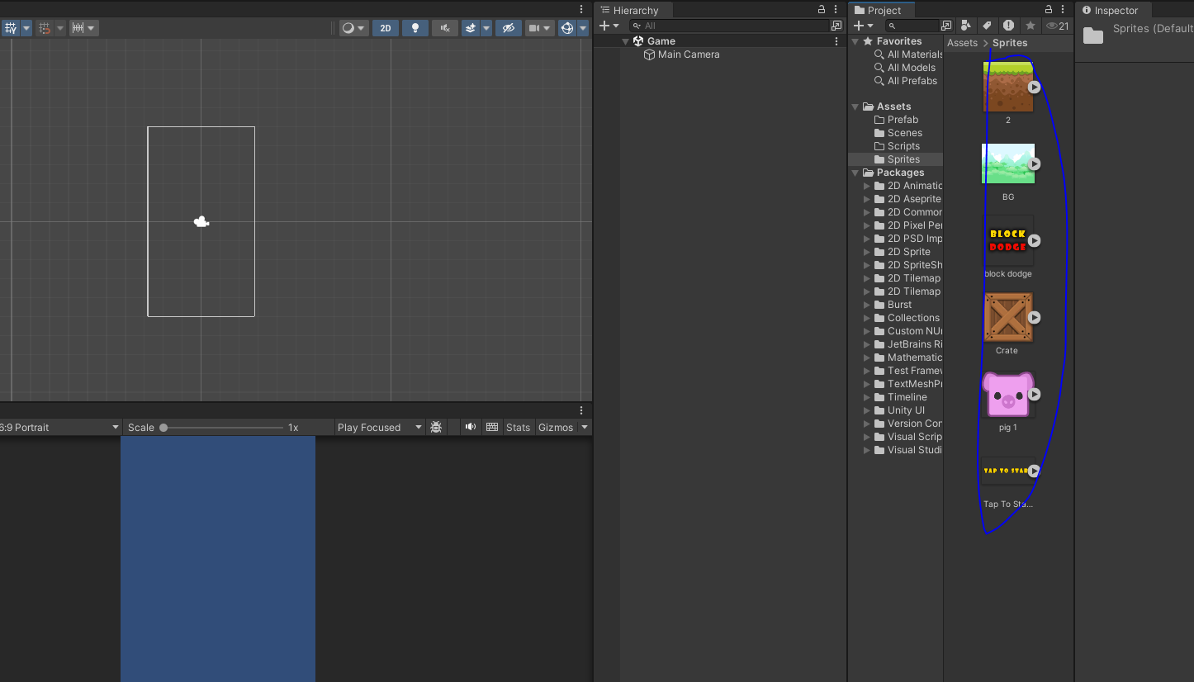
Teacher have doenloaded images for sprites from Game Art 2d.com

